Fundamentals of Programming

Home Task 2

Instructor: Sir Affan

Syed Muhammad Ali Akbar

477723

***Code***

#include <iostream>

using namespace std;

**//Task 1**

int main()

{

int marks;

cout<<"Enter your marks: "<<endl;

cin>>marks;

if(marks>=90&&marks<=100)

{

cout<<"Grade: A";

}

if(marks>=75&&marks<90)

{

cout<<"Grade: B";

}

if(marks>=60&&marks<75)

{

cout<<"Grade: C";

}

if(marks>=45&&marks<60)

{

cout<<"Grade: D";

}

if(marks>=0&&marks<45)

{

cout<<"Grade: F";

}

}

**//Task 2**

int main()

{

int num;

cout<<"Enter any number: ";

cin>>num;

if(num%2==0&&num%5==0)

{

cout<<"" <<num<< " is even and divisible by 5"<<endl;

}

else

{

cout<<"" <<num<< " is not both even and divisible by 5"<<endl;

}

}

**//Task 3**

int main()

{

int year;

cout<<"Enter year: "<<endl;

cin>>year;

if(year%4==0&&year%100!=0)

{

cout<<"" <<year<< " is a leap year"<<endl;

}

else if(year%4==0&&year%100==0)

{

if(year%400==0)

{

cout<<"" <<year<< "is a leap year"<<endl;

}

else

{

cout<<"" <<year<< "is not a leap year"<<endl;

}

}

else

{

cout<<"" <<year<< " is not a leap year"<<endl;

}

return 0;

}

**Task 4**

int main()

{

float att,gpa;

cout<<"Enter GPA: "<<endl;

cin>>gpa;

cout<<"Enter attendence percentage: "<<endl;

cin>>att;

if(att>=80 && gpa>=3.5)

{

cout<<"Eligible for scholarship"<<endl;

}

else

{

cout<<"Not eligible for scholarship"<<endl;

}

return 0;

}

**//Task 5**

int main()

{

char let;

cout<<"Enter a letter: "<<endl;

cin>>let;

if(let=='a'||let=='e'||let=='i'||let=='o'||let=='u')

{

cout<<"letter " <<let<< " is a vowel"<<endl;

}

else

{

cout<< "letter " <<let<<" is a consonant"<<endl;

}

return 0;

}

***Output:***

**Task 1**

**Task 2**

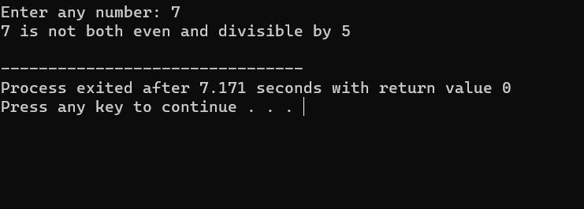

**Task 3**

**Task 4**

**Task 5**

